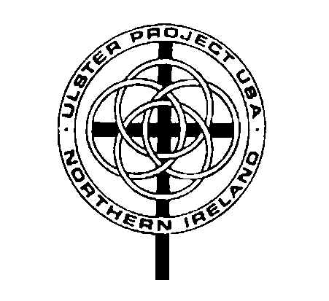

Meeting Agenda

Alliance Area Ulster Project

Date: November 5, 2018

Opening Prayer/Scripture: John 17:23 I in them and you in me—so that they may be brought to complete unity. Then the world will know that you sent me and have loved them even as you have loved me.

Attendance sheet- please sign in
- Treasurer’s report-
- Correspondence – Website
- Committee Reports- Auction update-Shirley
- Old business
- Host Families
- Officers/Delegating / List of active parents
- Child Protection renewal
- The Priests- concert at Palace Theater Nov. 17
- Confirmation- Elkhorn: June 29-July 1
- Other:

- New Business
- International conference: UP Conference expense-$200 Updates/Meeting with Jen Henderson and Massillon UP- Linda Reibenstein
- Auction- stuff & stamp envelopes
- Other:

Adjournment-Next meeting December 3 , 2018

